Instructions for Editing INDI Code on OS X using QT Creator.

1. Install INDI and KStars using the KStars on OS X Craft build script. It doesn’t matter which options you use as long as you don’t install the “stable” build because that would put your edits out of date with the rest of the repository.

<https://github.com/rlancaste/kstars-on-osx-craft>

1. Open QT Creator. If that is not installed yet, please see the QT website: <https://www.qt.io/download-qt-installer>
2. In Preferences, Select Kits: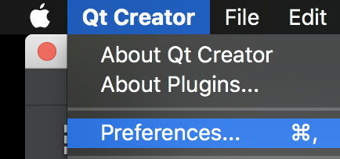 
3. Add the Craft CMAKE executable to the list of CMAKE executables in the cmake tab. 
4. To do this task, Click  and then 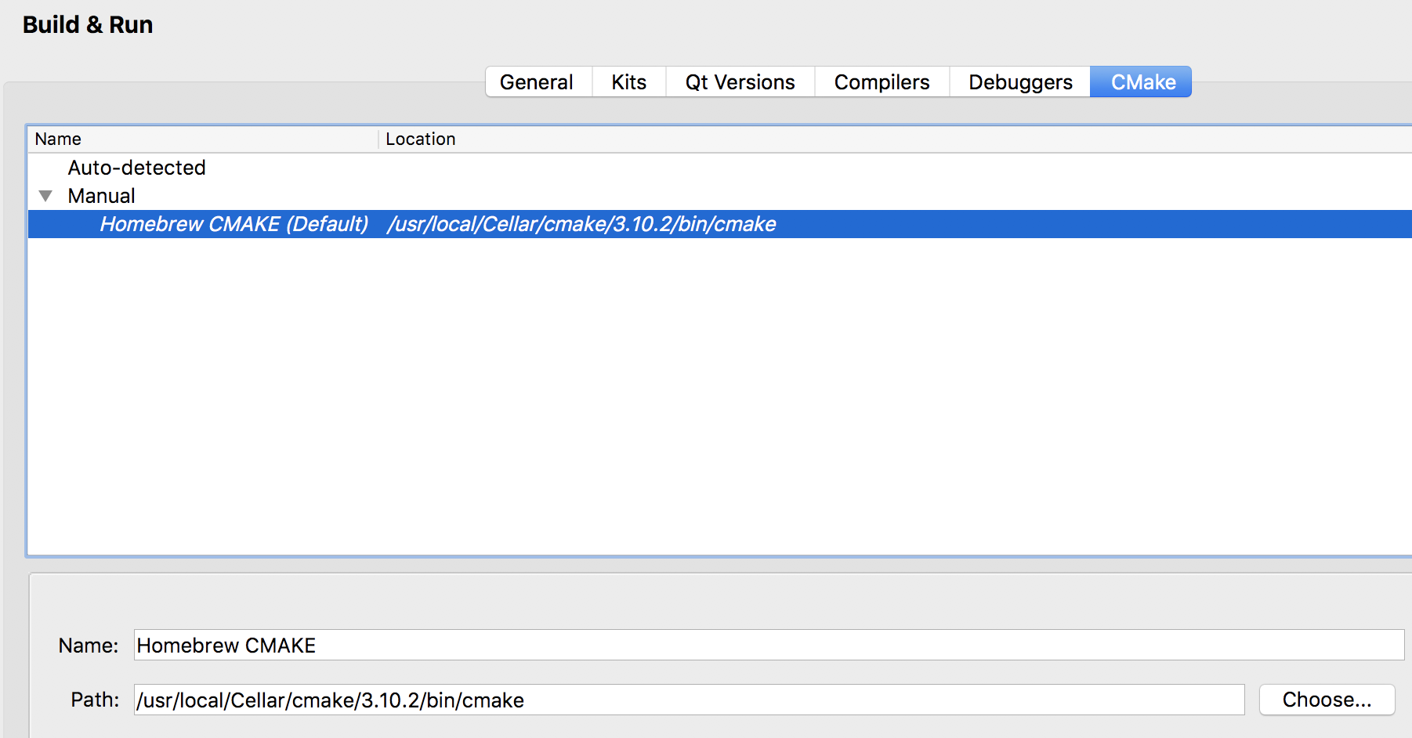 to find the path to CMake in Craft you will probably find it somewhere like this. Remember the name you give it since you will need it shortly in the next step:



1. Add the craft Qt version to the list of QT Versions if it is not in there yet. Click QT Versions



1. If the version in craft is not added, yet, click add and choose the directory.
2. Select Kits:



1. Click Add to configure a new Manual Kit. 
2. Select the following Options:



Note: The QT Version may differ depending on your QT installation and the Make tool you select should be the one you added in the step before.

1. Now set up the CMake Generator by clicking the Change button.



You will need to select the following options:



1. Finally setup the CMake Configuration by clicking the Change Button:



1. You will need to set the following options, add your craft root as shownx:

CMAKE_CXX_COMPILER:STRING=%{Compiler:Executable:Cxx}

CMAKE_C_COMPILER:STRING=%{Compiler:Executable:C}

CMAKE_INSTALL_PREFIX:STRING=~/AstroRoot/craft-root

CMAKE_PREFIX_PATH:STRING=%{Qt:QT_INSTALL_PREFIX};~/AstroRoot/craft-root

QT_QMAKE_EXECUTABLE:STRING=%{Qt:qmakeExecutable}

1. Finally click ok. 
2. Note that you might also need to install ninja in Homebrew. Just type brew install ninja on the command line.
3. Now we will need to get the INDI repository for editing. You can also edit INDI in the craft source and build folders (like we do with KStars), but this is the recommended method because it will be easier to deal with for INDI.
4. First, go to <https://github.com/indilib/indi> and click the “Fork” button.
5. Then edit the FORKED_INDI_REPO variable in the build-env.sh script in this repository to match your new INDI fork’s path



1. Then run the downloadINDIForkForEditing.sh script from this repository. Now you should have a folder called indi-work in your AstroRoot
2. Now, Click Open Project 
3. Navigate to and Select the INDI CMakeList.txt. Here is the path it will probably be at: ~/AstroRoot/indi-work/indi/libindi/CMakeLists.txt
4. Configure the project by selecting your custom “Craft Kit” and deselecting the default one. Also, you will probably want to deselect most of the build options and just use the default one.



1. You can create a folder in the indi-work folder called indi_build or something like that for building the code.
2. Select 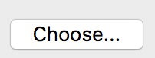 next to the Default Kit to select the path to the build folder. Something like this: ~/AstroRoot/indi-work/indi-build
3. Click the Configure Button:



1. Now you might get a popup dialog that looks like the following:

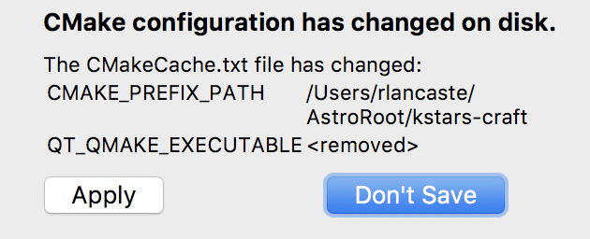

1. I clicked “Don’t Save” to this Dialog, but I don’t know.
2. Now you should see all of the files pop up on the left. You can edit these to make your changes.
3. Note that in order to test your changes, you will need to set the run configuration to test what you want to test. You will find that by clicking Projects and then selecting “Run” for the Craft Kit under “Build and Run.”
4. You should set the run configuration to run the indiserver executable with command line options as shown to run the drivers you want to test. In this example, I am running 3 simulator drivers.



1. Whenever you want to test your changes, just click the “Run” button on the left. You can connect equipment to your computer to test it with the drivers you are editing and You can connect to the INDIServer you are testing from KStars using the “external” indiserver option, but using localhost for the location.



**For Editing 3rd Party Drivers.**

Note that the 3rd Party drivers are in a different CMakeLists than the main libindi drivers. You should set up a separate project for them. Follow the directions above starting with “Open Project” with the following modifications:

The CmakeLists for 3rd Party is ~/AstroRoot/indi-work/indi/3rdParty/CMakeLists.txt

You should probably make a different folder for building such as

﻿~/AstroRoot/indi-work/3rdParty-build

And for testing the 3rd Party drivers, using the “Run Config” you will need to use the indiserver that you built in the previous step, so you need to select “Custom Executable” under the “Add” combo box. Then to run the driver you are working on, it needs the path to that driver. For example you can do this for editing dsi:

